USER MANUAL FOR “USER”

“LIMITER”

THE SMART PARKING SYSTEM

**1. Services Needed :**  
As the application is not submitted at any authorized source, the user will be needed to allow installation from unknown sources to install our application.  
  
**2. Permissions :**  
We will not be needing any permissions in this application  
  
**3.Launch Page :**  
Any user will be directed to the launch page after opening the application where they will have to choose in which mode they want to run the application (i.e user or admin) ,In this case we will only consider user one.

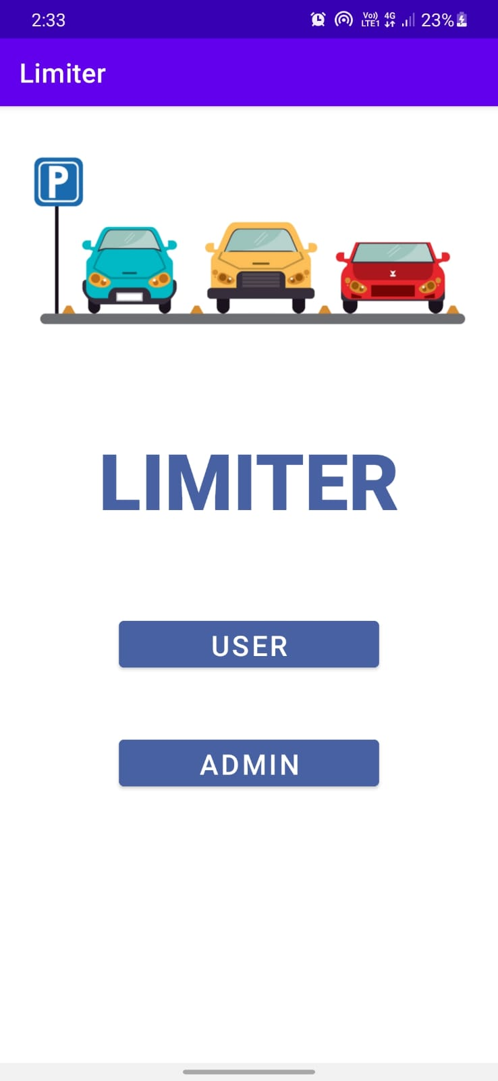

**4.User Login :**

If one decides to run the application in the user mode and clicks on “USER” , the app will be redirected to the user login.

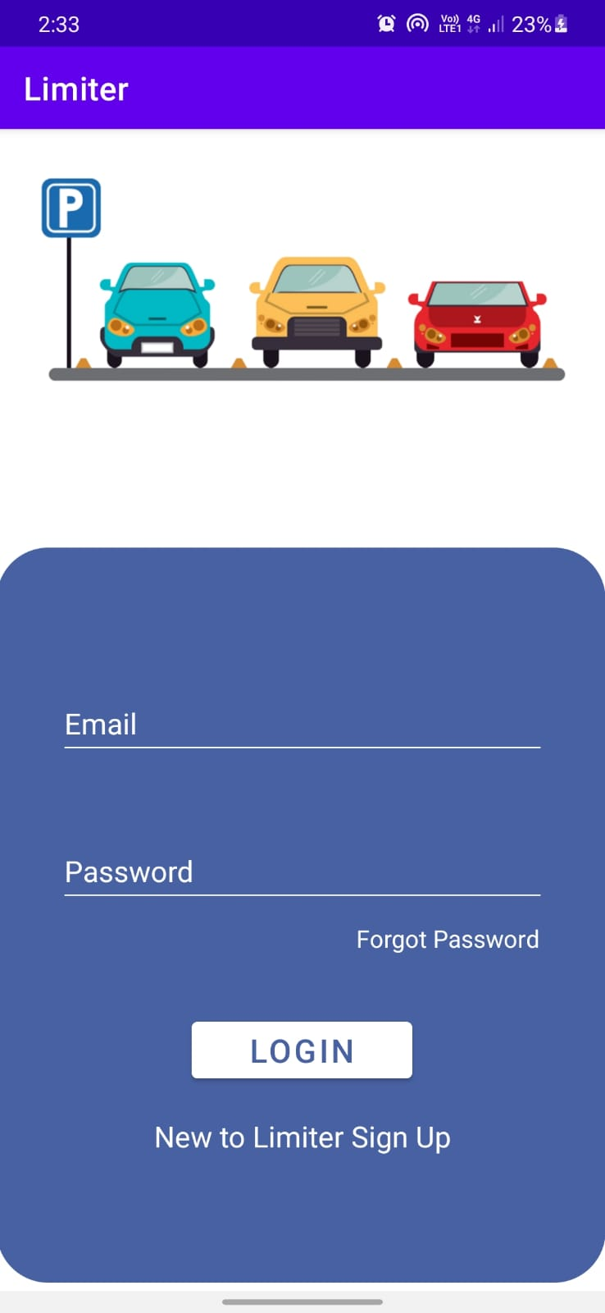

There are three cases here:

1. The user may enter the proper credentials , in that case we will redirect the user to the parking page.
2. If the user forgets the password and clicks on the “forgot password” button ,in that case we will show them a dialog box where they will need to enter the OTP that has been sent to them on their registered email ID. If the OTP is correct then they will be redirected to “change password page”.
3. If the user is new, he should click on the register button which will redirect the user to

“Register Page”.

{

To test this functionality,use the credentials of any of the following accounts:

**Email id:** iit2020191@iiita.ac.in **Password:** user@191

**Email id:** iit2020193@iiita.ac.in **Password:** user@193

**Email id:** iit2020194@iiita.ac.in **Password:** user@194

**Email id:** iit2020195@iiita.ac.in **Password:** user@195

}

**5. Register New User :**If the user is new to the application, they must click on Register New User button which will redirect the user here where the user will be asked to fill the mandatory details The user needs to enter an unregistered email address and a custom password (twice) and tap the “SIGN UP” button in order to register the new account. All the fields are mandatory.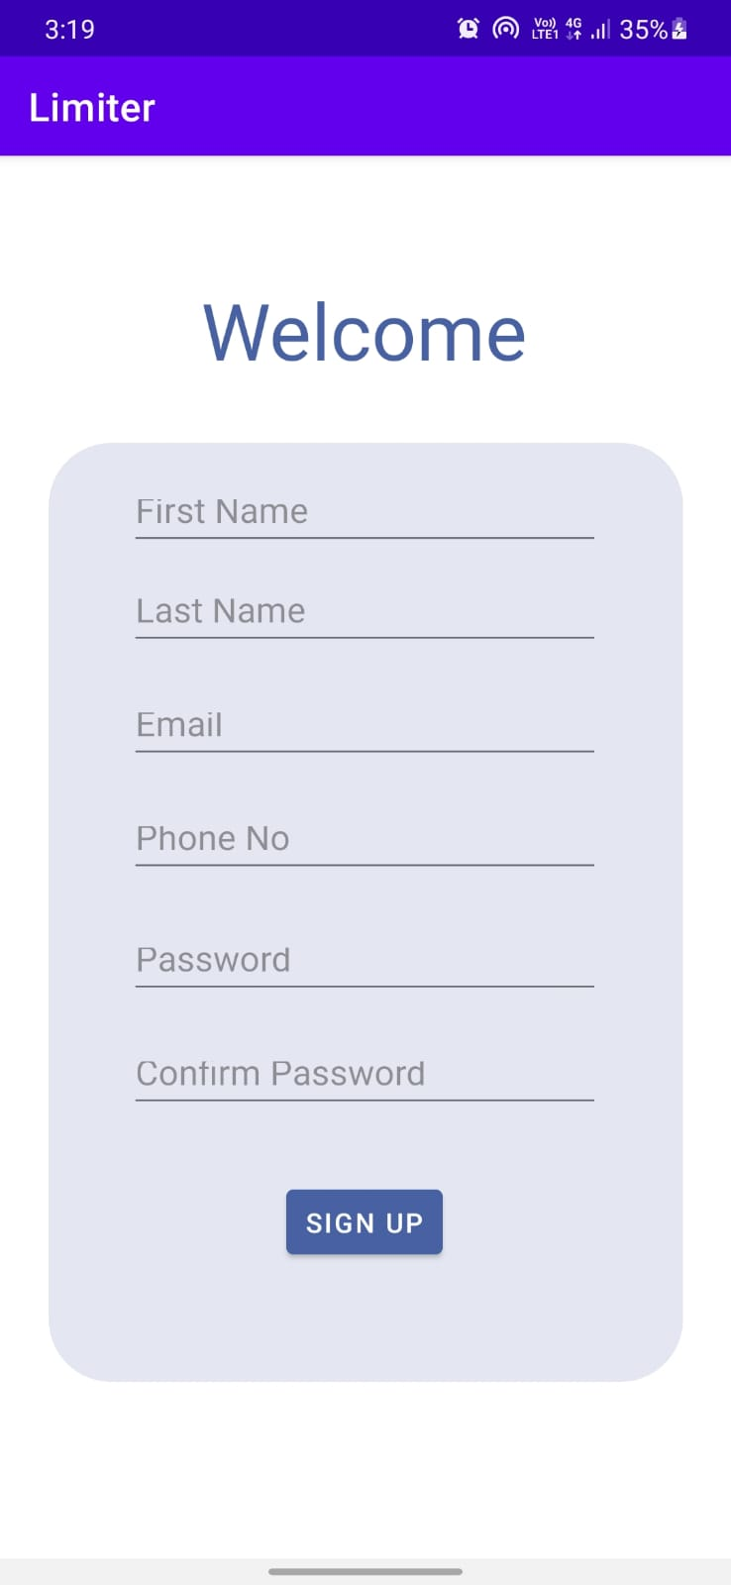

**6. Forgot Password(User) :**

The registered user can reset/change his/her password if needed by clicking on the forgot password in the login page of the user.

* **OTP verification**

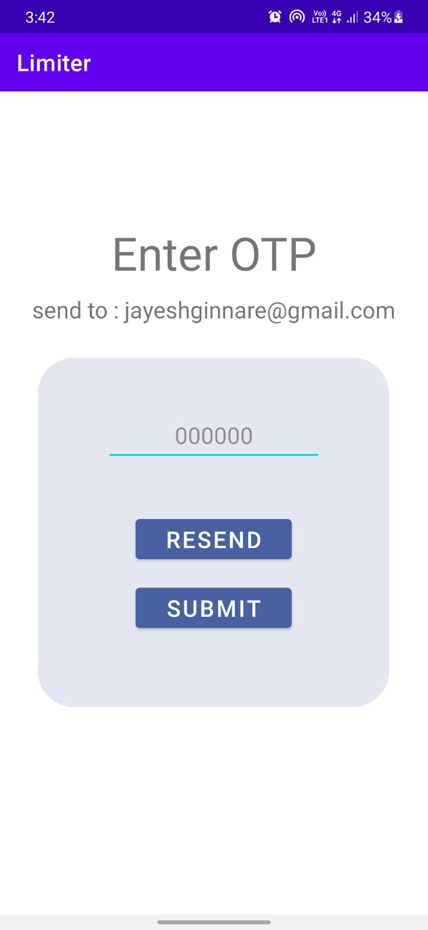

* OTP will be sended to the user’s email address.
* On successful verification of the OTP user will be redirected to the New password page.
* On failing the OTP verification, the user will be redirected to the login page.
* **Entering New Password**
* **Entering new password:** Users have to set a new password.
* **Reentering a new password:** Users have to reenter the new password for verification.

If both the password does not match then the user needs to re enter both the entries again which should be the same..

**7. Display Parking :**

Users can view the current parking status of the parking lot and from here he/she can book a parking space if available.

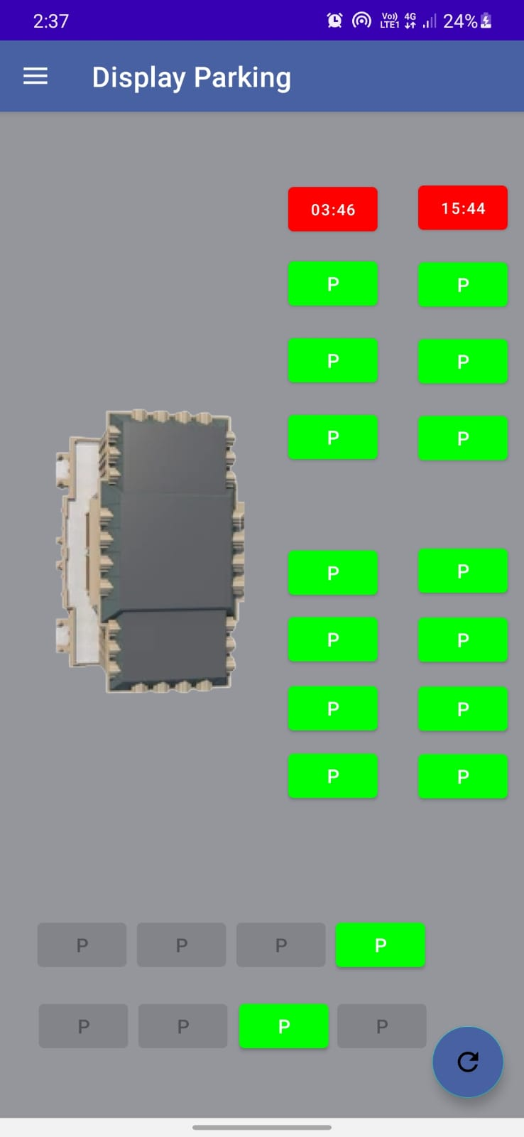

**8. Register Vehicle :**

Users have to enter all three details . All are mandatory.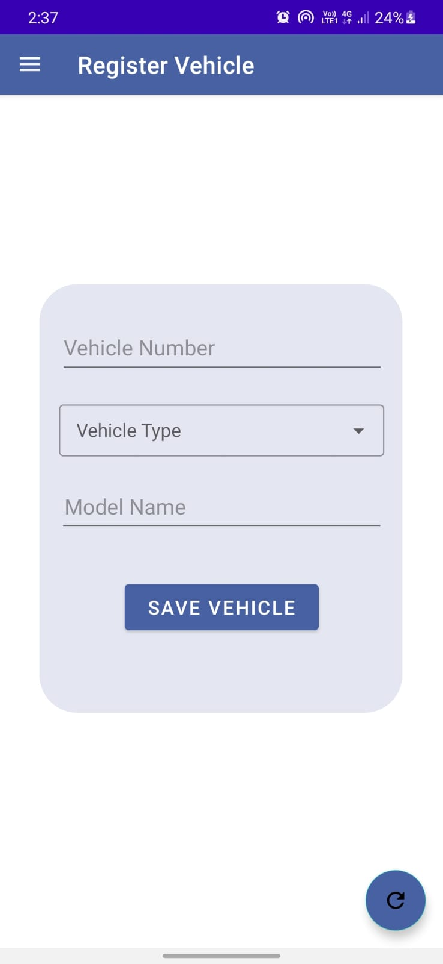

* **Enter vehicle number :** users have to enter vehicle number**.**
* **Select the vehicle type:** from the drop down list users have to select the vehicle type .
* **Enter Model name :** users have to enter the model name of their vehicle**.**

Then click on save vehicle

**9. Home Screen (user) :**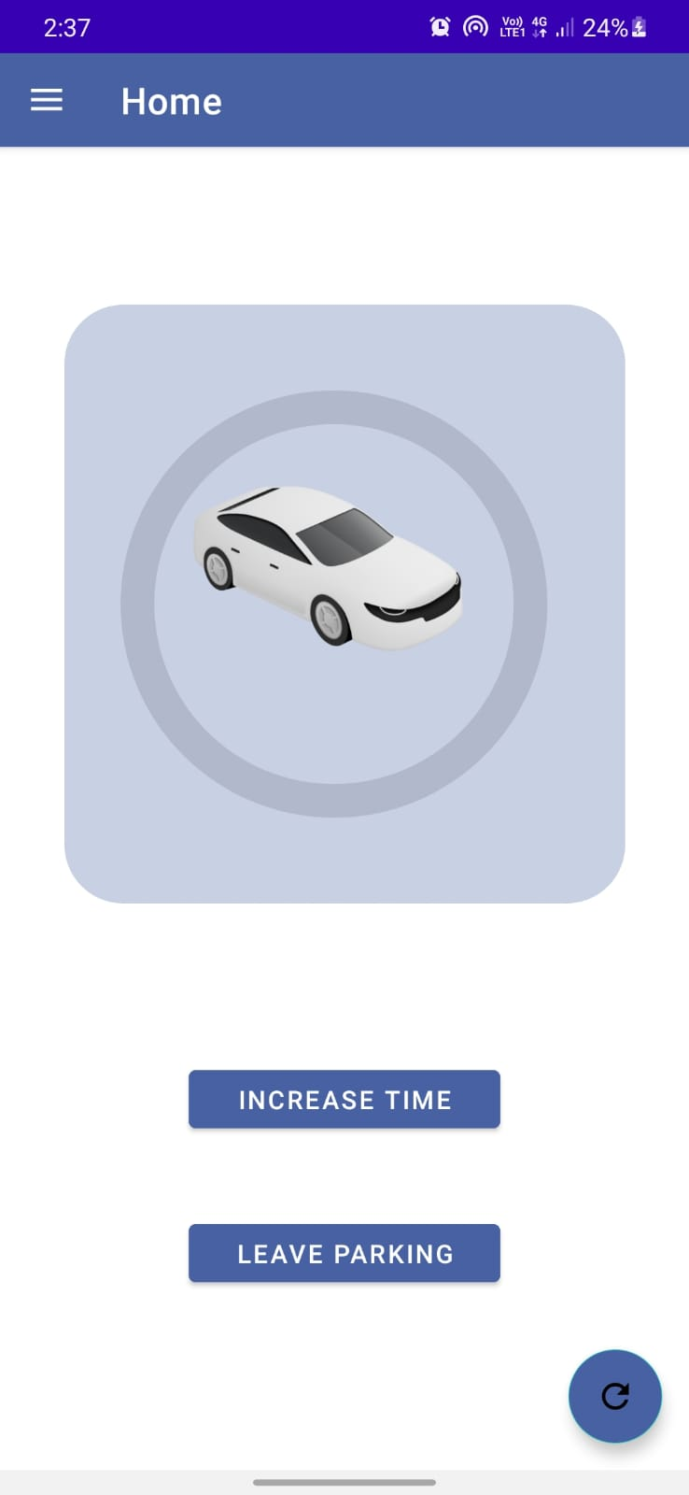

* **Increase the timer :** users can increase the timer of their parking slot if required some extra time**.**
* **leave parking space:** users can vacate the parking slot booked by him.

**10. FAQ :**

View faq written by admin for better clarification on particular functionalities of the application or parking management system. Which can be refreshed using the refreshing button.

